# CS 255 System Design Document Template

This template lays out all the different sections that you need to complete for Project Two. Each section has guidance to prompt your thinking. You will need to continually reference the interview transcript as you work to make sure that you are addressing your client’s needs. There is no required length for the final document. Instead the goal is to complete each section based on what your client’s needs are. Remove this note when you are finished, and replace all bracketed text with the relevant information.

## UML Diagrams

### UML Use Case Diagram

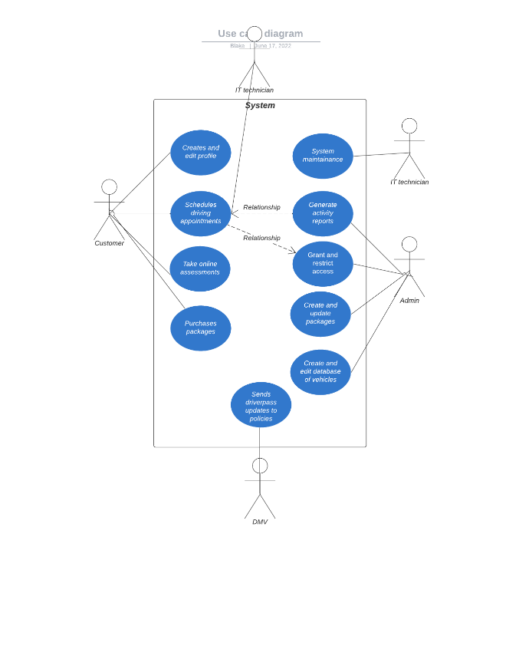

### UML Activity Diagrams

### 

### UML Sequence Diagram

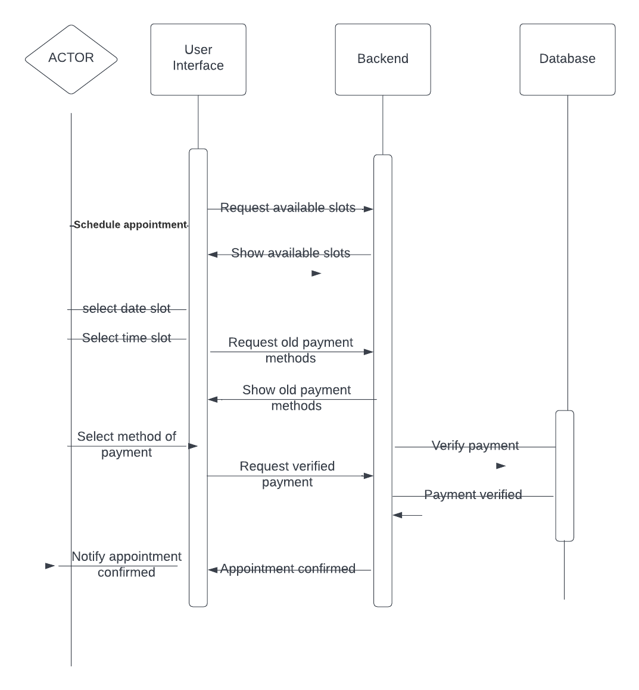

### UML Class Diagram

*[You were asked to create a class diagram based on the different classes and attributes needed for your system design. You are* ***not*** *required to include methods, but you may if you wish. Please insert your class diagram here. Check to make sure that you included appropriate components and symbols and that your design meets the client’s requirements.]*

## Technical Requirements

The system should be able to be up 24/7 and allow for users to always have access. The platform should be able to run on Linux and will use cloud to manage security and take care of the databases. The cloud will be responsible for managing all communications between client and server.